# Computational Domain:

A full 3D computational domain was meshed with a non-uniform, hexahedral grid using ANSYS ICEM-CFD 16.1.

**Bluff body**

Figure 10.1(a)

A 90° symmetry sector has been taken from the complete domain, shown in figure 9.1(a), as the computational domain. In this case the blocking was done with a top-down approach [11] using O-Grid[11].Internal O-Grid was generated for the whole domain and was merged & splitted, as per required, for certain locations in the domain which assured very good quality meshes there itself specifically at locations i.e. Fuel inlet, bluff body surface. A hierarchy of 3 meshes were constructed for this validation viz. Mesh 1, Mesh 2 and Mesh 3. The cell size for Mesh 2 was reduced to one half in each direction,compared to Mesh 1, and for Mesh 3 the cell size was reduced to one third in each direction, compared to Mesh 2. The grid refinement was concenterated close to the body so that the near wall effects can be resolved appropriately and also to capture the important physical phenomenon occuring behind the bluff-body . The grid was coarsened gradually towards the outlet.

From figure 10.1(b)[15], it is seen that the computational domain extends 6.08DB downstream the face of bluff body and it ensured that the outlet bounday is sufficently far enough in order that it doesn not interfere in the flow development.The fuel jet pipe extended 90 mm upstream from the face of bluff body to ensure that the velocity profile and turbulence quantities were fully developed at the exit plane, as in the experiment. The domain extended 1.5DB in the radial direction so that the wall effects are negliglible on to the flow development behind the bluff body. Also it extends 1.5 DB in the negative z-direction.

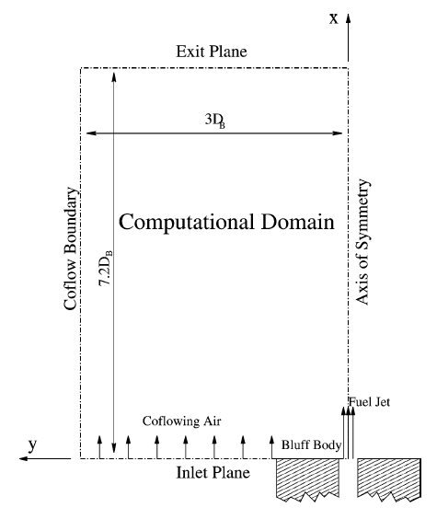

6.08 DB

**Computational Domain**

1.5 DB

Figure 10.1(b)

Figure 10.1 (b) shows the 2d symmetric impression of the computational domain. Following table shows the details of the mesh heirarchy:

|  |  |  |  |
| --- | --- | --- | --- |
| Parameter | Mesh 1 | Mesh 2 | Mesh 3 |
| Elements | 445779 | 3649862 | 12367909 |
| Nodes | 477248 | 3773055 | 12648672 |
| Maximum Aspect Ratio | 665 | 1864 | 3046 |
| Minimum Grid Angle | 45° | 44.19° | 40.95° |
| Max Y+ on bluff body | 6.23 | 3.08 | 2.01 |

Table 9

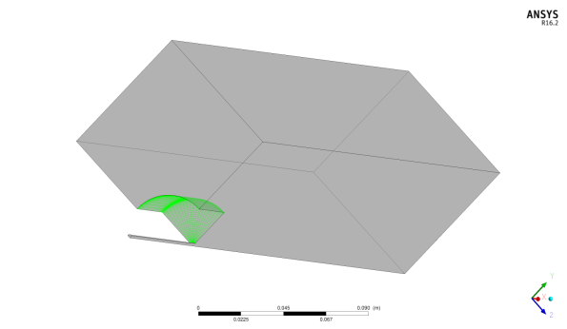

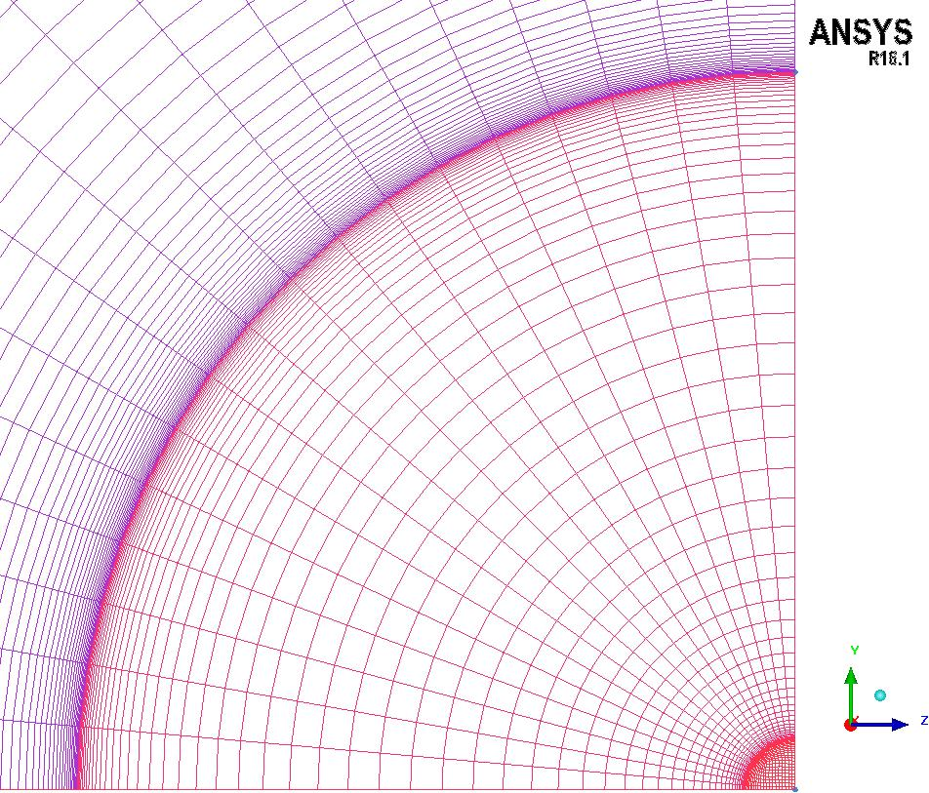

**Mesh 1**

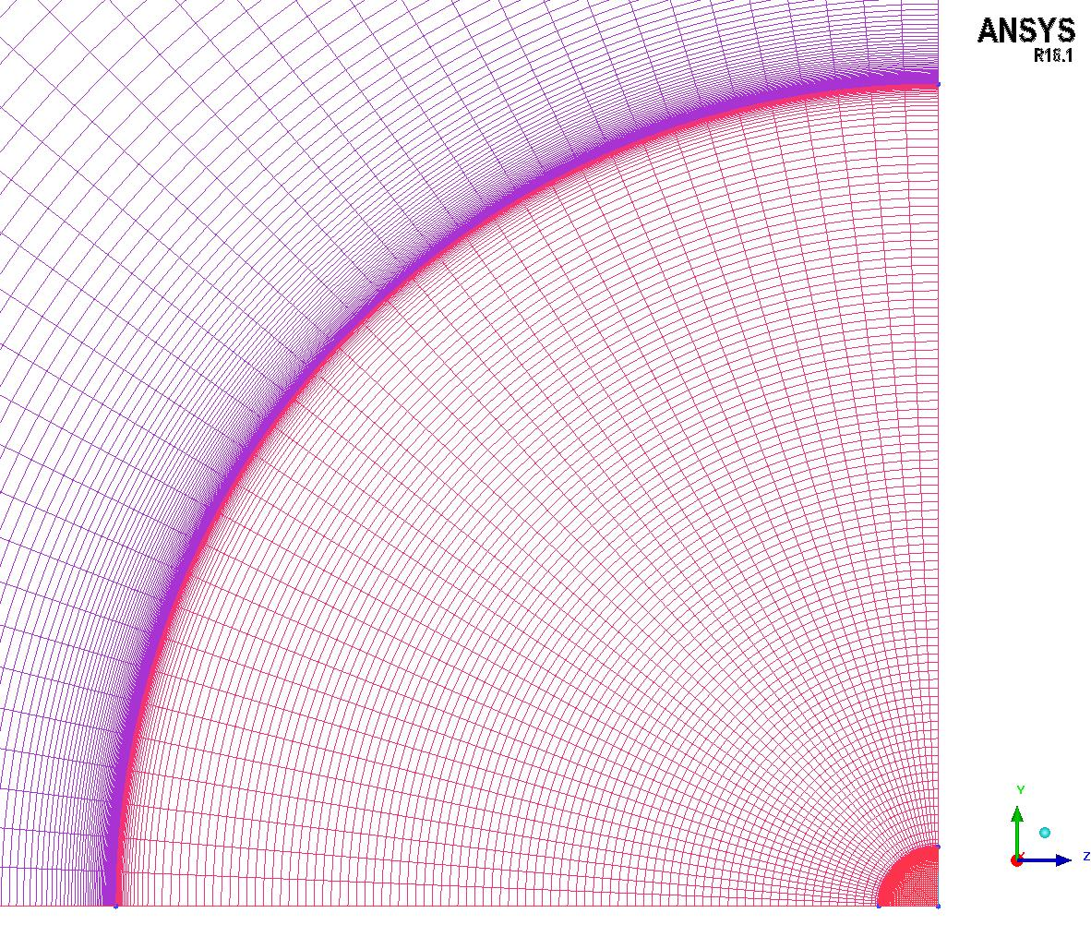

**Mesh 2**

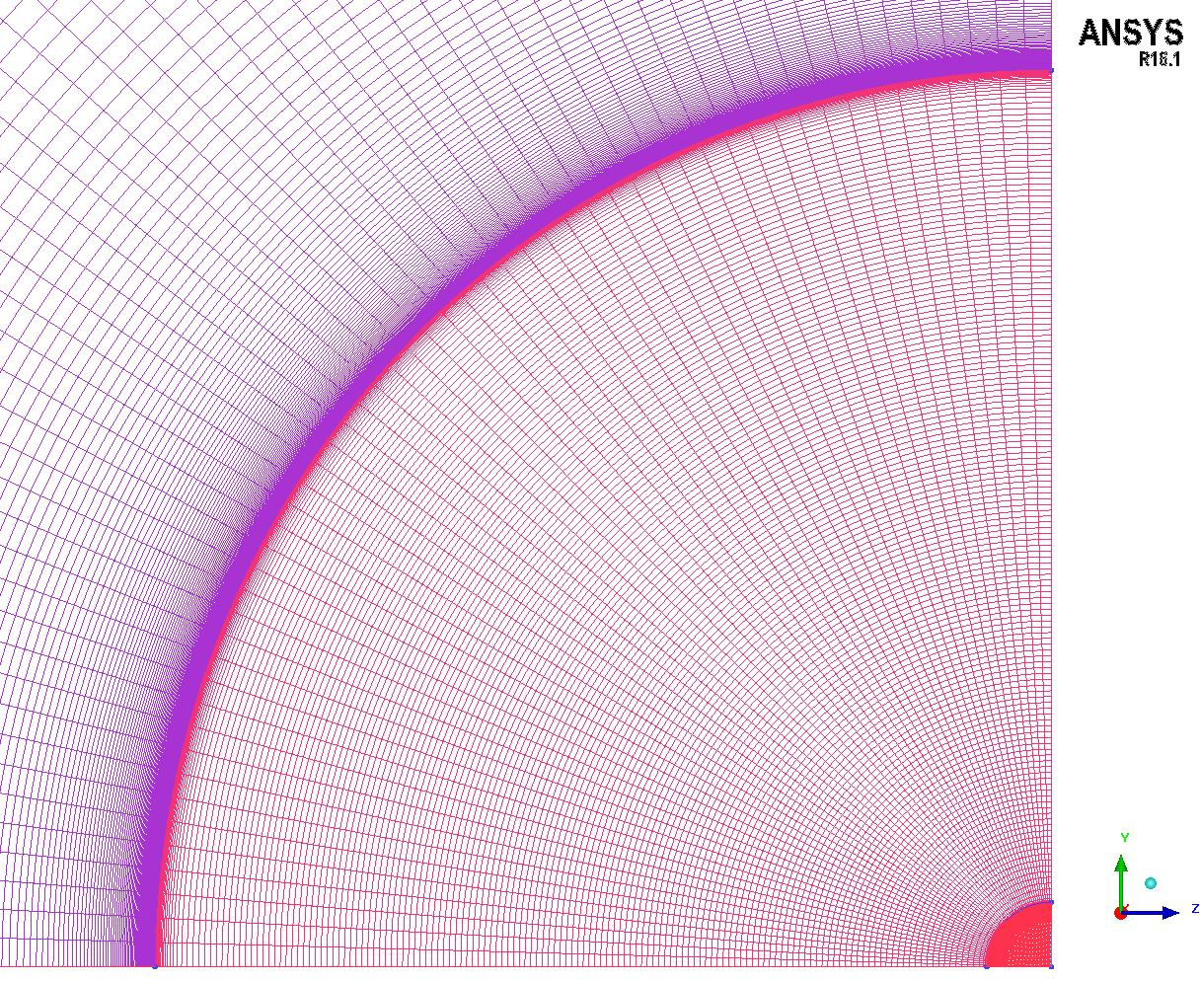

**Mesh 3**

Figure 10.1(c)

Figure 10.1(c) shows the visual comparison of the three mesh resolution. The quality assurance studies and the inspection of the results performed here are similar to that mentioned in chapter 6, but additional quality assurance criteria were not performed here.